 | 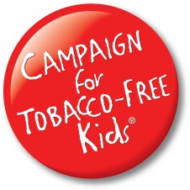 | 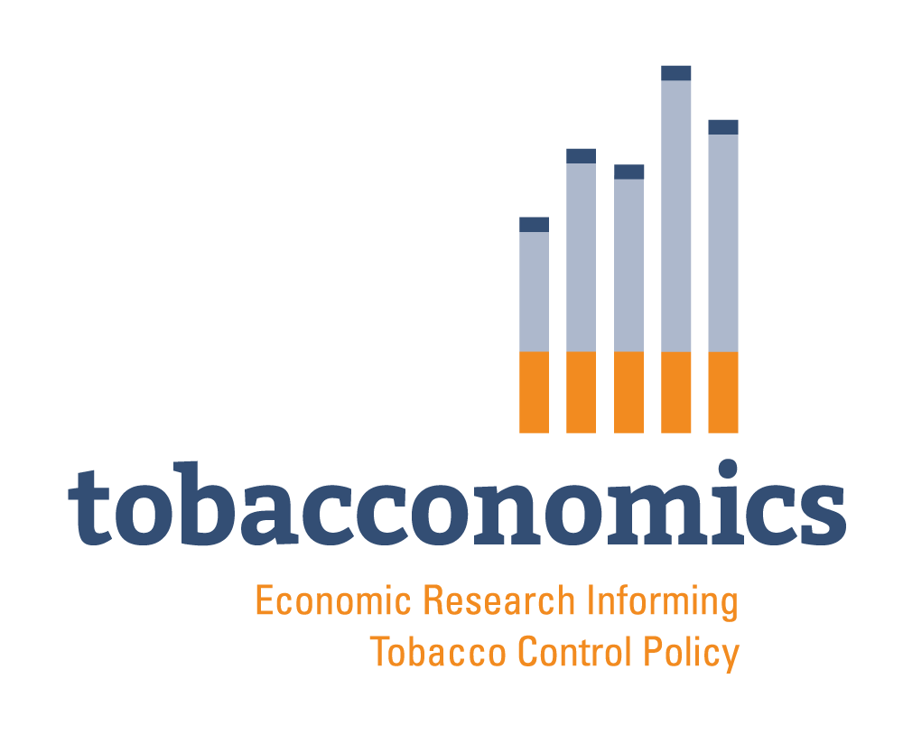

new Revenues, public health Benefits & Cost Savings
from A $1.50 Cigarette Tax Increase in mississippi

- The current state cigarette tax is $0.68 per pack (40th among all states and DC).

- Annual health care expenditures in Mississippi directly caused by tobacco use are $1.23 billion.

Projected New Annual Revenue from Increasing the Cigarette Tax by $1.50 Per Pack: $142.23 million
Additional Revenue from Raising Other Tobacco Product Tax Rates to Parallel New Levels: $30.80 million
New Annual Revenue is the amount of additional new revenue the first full year the tax increase is in effect. The state will collect less new revenue if it fails to apply the rate increase to all cigarettes and other tobacco products held in wholesaler and retailer inventories on the effective date. Projected revenue for other tobacco products does not include e-cigarettes.

Projected Public Health Benefits for Mississippi from the Cigarette Tax Rate Increase
Percent decrease in youth (under age 18) smoking: | 14.5%
Youth under age 18 kept from becoming adult smokers: | 8,800
Reduction in young adult (18-24 years old) smokers: | 1,700
Current adult smokers who would quit: | 19,300
Premature smoking-caused deaths prevented: | 7,400
5-Year reduction in the number of smoking-affected pregnancies and births: | 2,300
5-Year health care cost savings from fewer smoking-caused lung cancer cases: | $3.88 million
5-Year health care cost savings from fewer smoking-affected pregnancies and births: | $6.38 million
5-Year health care cost savings from fewer smoking-caused heart attacks & strokes: | $9.41 million
5-Year Medicaid program savings for the state: | $1.81 million
Long-term health care cost savings from adult & youth smoking declines: | $584.53 million
12.28.20 ACS CAN / January 12, 2021

- Small tax increase amounts do not produce significant public health benefits or cost savings because the cigarette companies can easily offset the beneficial impact of such small increases with temporary price cuts, coupons, and other promotional discounting. Splitting a tax rate increase into separate, smaller increases in successive years will similarly diminish or eliminate the public health benefits and related cost savings (as well as reduce the amount of new revenue).
- Raising state tax rates on other tobacco products (OTPs), including e-cigarettes, to parallel the increased cigarette tax rate will bring the state additional revenue, public health benefits, and cost savings (and promote tax equity). With unequal rates, the state loses revenue each time a cigarette smoker switches to other tobacco products taxed at a lower rate. To parallel the new $2.18 per pack cigarette tax, the state’s new OTP tax rate should be 42% of the wholesale price with minimum tax rates for each major OTP category linked to the state cigarette tax rate on a per-package or per-dose basis.

Explanations & Notes

Health care costs listed at the top of the page are from the U.S. Centers for Disease Control and Prevention (CDC). Annual health care expenditures in Mississippi directly caused by tobacco use are in 2009 dollars and are from the CDC’s 2014 Best Practices for Comprehensive Tobacco Control Programs.

Projections are based on research findings that nationally, each 10% increase in the retail price of cigarettes reduces youth smoking by 6.5%, young adult prevalence by 3.25%, adult prevalence by 2%, and total cigarette consumption by about 4% (adjusted down to account for tax evasion effects). However, the impact of the tax increase varies from state-to-state, based on the starting pack price. Significant tax increases generate new revenues because the higher tax rate per pack brings in more new revenue than is lost from the tax-related drop in total pack sales.

The projections also incorporate the effect of ongoing background smoking declines, population distribution, and the continued impact of any recent state cigarette tax increases or other changes in cigarette tax policies on prices, smoking levels, and pack sales.

These projections are fiscally conservative because they include a generous adjustment for lost state pack sales (and lower net new revenues) from possible new smuggling and tax evasion after the rate increase and from fewer sales to smokers or smugglers from other states, including sales on tribal lands. For ways that the state can protect and increase its tobacco tax revenues and prevent and reduce contraband trafficking and other tobacco tax evasion, see the Campaign for Tobacco-Free Kids (CTFK) factsheet, State Options to Prevent and Reduce Cigarette Smuggling and to Block Other Illegal State Tobacco Tax Evasion, https://www.tobaccofreekids.org/assets/factsheets/0274.pdf.

Projected numbers of youth prevented from smoking and dying are based on all youth ages 17 and under alive today. Projected reduction in young adult smokers refers to young adults ages 18-24 who would not start smoking or would quit as a result of the tax increase. Savings to state Medicaid programs include estimated changes in enrollment resulting from federal laws in effect as of January 1, 2021, state decisions regarding Medicaid expansion, and the impact of COVID-19. Long-term cost savings accrue over the lifetimes of persons who stop smoking or never start because of the tax rate increase. All cost savings are in 2021 dollars.

Projections for cigarette tax increases much higher than $1.00 per pack are limited, especially for states with relatively low current tax rates, because of the lack of research on the effects of larger cigarette tax increase amounts on consumption and prevalence. Projections for cigarette tax increases much lower than $1.00 per pack are also limited because small tax increases are unlikely to produce significant public health benefits.

Ongoing reductions in state smoking rates will, over time, gradually erode state cigarette tax revenues, in the absence of any new rate increases. However, those declines are more predictable and less volatile than many other state revenue sources, such as state income tax or corporate tax revenues, which can drop sharply during recessions. In addition, the smoking declines that reduce tobacco tax revenues will simultaneously produce much larger reductions in government and private sector smoking-caused health care and other costs over time. See the CTFK factsheet, Tobacco Tax Increases are a Reliable Source of Substantial New State Revenue, https://www.tobaccofreekids.org/assets/factsheets/0303.pdf.

The projections in the table on this fact sheet were generated using an economic model developed jointly by the Campaign for Tobacco-Free Kids and the American Cancer Society Cancer Action Network and are updated annually. The projections are based on economic modeling by researchers with Tobacconomics: Frank Chaloupka, Ph.D., and John Tauras, Ph.D., at the Institute for Health Research and Policy at the University of Illinois at Chicago, and Jidong Huang, Ph.D., and Michael Pesko, Ph.D., at Georgia State University. The state Medicaid cost savings projections, when available, are based on enrollment and cost estimates by Matt Broaddus at the Center on Budget and Policy Priorities using data from the Centers for Medicare and Medicaid Services.

For other ways states can increase revenues (and promote public health) beyond just raising cigarette tax rates, see the CTFK factsheet, The Many Ways States Can Raise Revenue While Also Reducing Tobacco Use and Its Many Harms & Costs, https://www.tobaccofreekids.org/assets/factsheets/0357.pdf.

Additional information and resources to support tobacco tax increases are available at:
https://www.tobaccofreekids.org/what-we-do/us/state-tobacco-taxes/fact-sheets
http://acscan.org/tobacco/taxes/
http://tobacconomics.org/

For more on sources and calculations, see https://www.tobaccofreekids.org/assets/factsheets/0281.pdf or https://www.fightcancer.org/policy-resources/state-tobacco-tax-increases-explanations-and-sources-projections-new-revenues.

Ann Boonn, Campaign for Tobacco-Free Kids
Frank J. Chaloupka, Tobacconomics
Katie McMahon, American Cancer Society Cancer Action Network

